*Fig a. XG Boosting model Accuracy*

*Fig b. MLP model Accuracy*

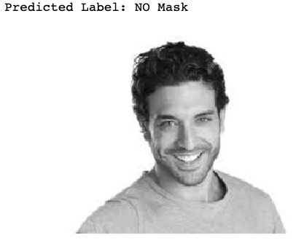

*Fig c. XG Boosting Model Result*

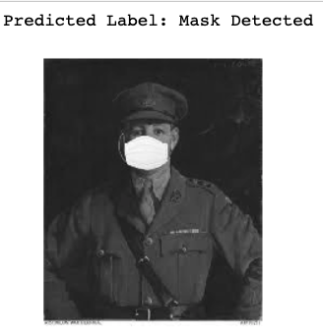

*Fig d. MLP model result*

*Fig e. XG Boosting Model Confusion Matrix*

*Fig f. MLP model Confusion Matrix*